Support unit assessment guidelines

administrative & Academic and Student support services

Updated August 2023

Table of Contents
Introduction 1
The Liaison Role in the Assessment Process 1
How to Use This Manual 1
Providing Assessment Feedback in HelioCampus (Formerly AEFIS) 2
Types of Feedback 2
Tips for Providing Meaningful Qualitative Feedback 3
Timing of Feedback 3
Submitting Feedback 4
Form History 5
Feedback Considerations & Boilerplate Feedback 6
Department/Unit Purpose 7
Outcomes 8
Measures 9
Targets 11
Findings 12
Use of Results (Data-Informed Actions) 14
Status Update on a Previously Identified Action (Closing the Loop) 16

Introduction

The Liaison Role in the Assessment Process
As Assessment Liaisons you serve an important role to the support units in your division and/or on your campus as well as to OIEE as an intermediary to support units for communication about assessment.
The role of the Liaison is as follows:
- Provide feedback and guidance to units/departments on the Assessment Plan and Report;
- Reinforce the importance of complete and timely Assessment Reports for purposes of compliance; and,
- Provide updates on unit/department changes and Program Coordinator access to OIEE.

How to Use This Manual
This manual explains the feedback process and includes specific guidance on providing feedback in each section of the Assessment Plan and Report. The tables in the “Feedback Considerations & Boilerplate Feedback” section include frequently cited areas for Plan and Report improvement and the corresponding feedback that can be copy/pasted into the feedback text boxes in HelioCampus (formerly AEFIS).

Providing Assessment Feedback in HelioCampus (Formerly AEFIS)

Types of Feedback
Feedback in the program assessment review process takes two forms:
- Categorical Dropdown: Yes, No, Not Applicable
“Yes” should be selected only in cases where the criterion is completely fulfilled. “Not Applicable” should be selected in instances where a particular criterion is not relevant to the outcome, measure, finding, etc.
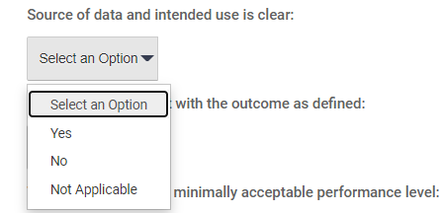
For example: Assessment Plans for administrative units are not expected to focus their outcomes on student or faculty success, so “Not Applicable” is the appropriate selection for that criterion in the Use of Results section.
- Qualitative
Each section of the Plan/Report includes a text box where qualitative feedback can be provided. OIEE recommends providing qualitative feedback in sections where “No” is selected for any of the related criteria.
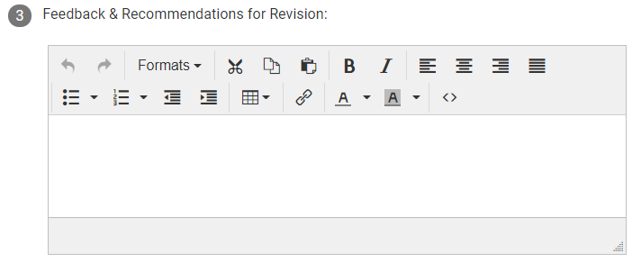

Tips for Providing Meaningful Qualitative Feedback
Since the implementation of HelioCampus (formerly AEFIS) for support unit assessment at Texas A&M, OIEE has received feedback from Program Coordinators that it is not always clear when each piece of feedback is provided. That is, it is sometimes difficult to tell whether feedback was provided during the Plan stage or during the Report stage. This is particularly applicable when feedback is updated or added to the Plan sections during the Report stage (at Step 4), which is sometimes necessary when significant changes have been made to the Plan mid-cycle. Confusion may also occur when a form is rejected multiple times, each time with added feedback.
OIEE recommends one of two strategies (or a combination of the two) for making the timing of feedback clearer to Program Coordinators:
- Date the feedback.

This strategy follows accessibility standards. Below are two examples.
- 4/15/21: It isn’t clear how this measure addresses the outcome as defined. Please provide more information to make this alignment clearer.
- 11/10/21: The update to this section has made the relationship to the outcome and measure much clearer. Nice work!

- Color code the different iterations of feedback.

This strategy sets your qualitative feedback apart from the rest of the text in the form. Below are two examples.

- It isn’t clear how this measure addresses the outcome as defined. Please provide more information to make this alignment clearer. [Plan-stage feedback is blue]
- The update to this section has made the relationship to the outcome and measure much clearer. Nice work! [Report-stage feedback is orange]

Timing of Feedback
When Program Coordinators begin submitting Plans/Reports for feedback, you will periodically receive notifications from HelioCampus reminding you to log in and check for submissions. The Plan deadlines are essentially suggestions; there is some leeway with those deadlines because actual assessment of the outcomes in the Plan usually does not begin until later, depending on the calendar the unit follows.
Report deadlines are stricter because there are more workflow steps for the forms to go through during the Fall semester.

Submitting Feedback
If after providing feedback you do not wish to review the form a second time after revisions are made by the Program Coordinator, select the “Approve” button. Once the button is highlighted, click “Submit” to send the feedback forward in the workflow to the Program Coordinator for final revisions.
The “Reject” button can be used if you would like to review the Plan or Report again before it advances to the next workflow step(s). Select the “Reject” button and click “Submit” to send the form with feedback backwards in the workflow to the Program Coordinator. This action ensures you will see the form again after the Program Coordinator makes changes.
Use your best judgment to determine which units might benefit from more than one round of feedback on the Plan/Report.
NOTE: Please note that the HelioCampus system will automatically notify Program Coordinators via email when one of their assessment forms is rejected back to them.
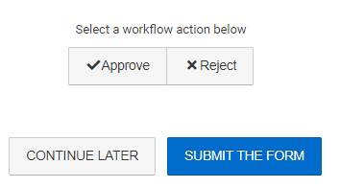

Form History
The Form History feature allows Liaisons to see the changes Program Coordinators have made to the assessment form between feedback iterations. To access Form History, click the Show History icon at the top right of the assessment form:
The first section of the Form History menu, labeled Form Actions (seen in the screenshot below), shows the submission history for the assessment form, including date, time, whether it was sent forward in the workflow (Action: Proceed/Approved) or backward (Action: Rejected), and by whom.
The second section of the Form History menu, labeled Form Update History, shows a list of “sessions” during which Program Coordinator(s), Liaison(s), and/or OIEE staff were working in the form. Expanding a session entry will show every change made in the form during that session. Each change is timestamped and labeled with the user’s name. Clicking on an individual change within this list will automatically navigate you to that section of the form.
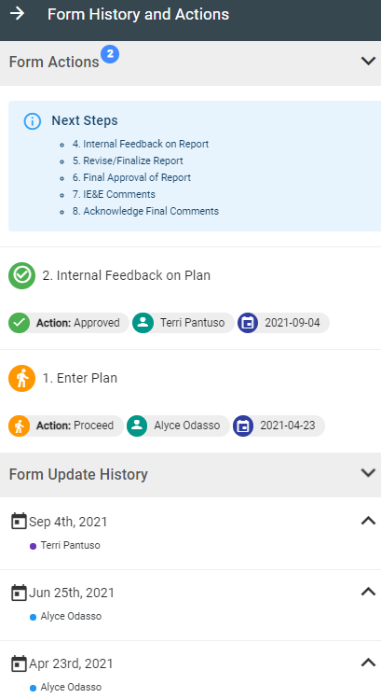

Feedback Considerations & Boilerplate Feedback
Considerations and boilerplate feedback for each section of the Assessment Plan and Report are on the following pages. The boilerplate feedback can be copy/pasted into the qualitative feedback fields in HelioCampus (formerly AEFIS). We recommend using the Word document version of this manual to do so; it is linked on the OIEE Assessment website (Liaison page). In the tables that follow, frequently cited areas for improvement are listed in the left column and the related boilerplate feedback is listed in the right column.

Liaisons are not required to use this feedback verbatim. The feedback may be customized as necessary and more detailed feedback may be provided to units that might require more guidance. Ultimately these boilerplate statements are meant to support you in your role by streamlining the feedback process.

Feedback is embedded in the assessment process to help units understand and utilize assessment best practices, but this is also a good opportunity to acknowledge good work.

Department/Unit Purpose

Description of the Unit: This may resemble a mission statement, such as the one published on their website. There are not any categorical review criteria specifically related to the description they provide.
Primary Groups Served: Program Coordinators are asked to describe the primary groups served by the unit (e.g., unique student populations, faculty, staff, prospective students, etc.). Units serving students should also explicitly indicate whether the students they serve are at a single location or multiple locations (and if so, which locations). Units responsible for providing or overseeing the provision of support services to all TAMU students (regardless of mode of delivery or geographic location) should clearly state this and describe the strategies used to ensure the identified outcomes are being met.

Boilerplate Feedback
Frequently Cited Area | Feedback
Academic & Student Support Units:  No reference to location of services | Units responsible for providing or overseeing the provision of support services to all TAMU students (regardless of mode of program delivery or geographic location) should clearly state this. Units responsible for providing or overseeing the provision of support services only to local students should clearly indicate this as well.

Outcomes
Meaningful Process: Outcomes selected for assessment in the upcoming academic/fiscal/calendar year should be the result of an intentional decision-making process. Encourage Program Coordinators to begin this discussion with staff and leadership well in advance of when Assessment Plans are due. Some units may find themselves on autopilot and continue to assess the same one or two outcomes every year. If you notice this, encourage units to consider other outcomes that will help determine how they are carrying out other parts of the unit’s mission.
Completion-Based Outcomes: Units planning to implement a new project or task, or those that are about to engage in an audit of their internal processes sometimes wish to create an outcome that reflects the successful completion of that project or task. These completion-based outcomes should be avoided as their eventual dichotomous results (e.g., Completed/Not Completed) ultimately don’t provide meaningful information on which to base continuous improvement efforts, nor do they fit into the cyclical assessment process. Outcomes centered around new tasks or projects should instead focus on the impact of that task or project (e.g., client satisfaction, increase in efficiency or effectiveness, etc.).

Boilerplate Feedback
Frequently Cited Area | Feedback
Outcome is multi-faceted/complex  (If the measurement strategy addresses all parts of the outcome, this is fine) | Outcomes can be difficult to measure completely when they are complex in nature. Parts of the outcome may get lost when the time comes to collect data. Keep outcomes focused on a single goal or process to make the assessment strategy more meaningful
Outcome is focused on completion of a task or project | Completion-based outcomes usually result in dichotomous results that aren’t very meaningful in guiding continuous improvement efforts. This outcome would be stronger if it was focused on the impact of the completed task/project.

Measures
Multiple Sources of Evidence: Units are strongly encouraged to use more than one measure to obtain evidence of an outcome, when possible and as applicable. Measures can be either qualitative or quantitative.
Supporting Documentation: Supporting documents such as surveys, spreadsheet templates, sample reports, and rubrics are always useful to include, but are not necessarily required if all aspects of the measure are thoroughly described in the Measure Description.
Completion of a Task or Project as a Measurement Strategy: As noted in the Outcomes section, reporting the completion of a task or project does not provide the kind of data that can be used to continually improve the unit and its processes. Instead, the impact of that new task or project should be the focus of the outcome and measurement strategy. As a rule, measures should reflect methodology that could result in some variability of scores or results over time (i.e., NOT Yes/No or Complete/Incomplete).

Boilerplate Feedback
Frequently Cited Area | Feedback
For units responsible for providing/ overseeing the provision of support services to students in other locations:  Measure description does not address how services at each location are assessed | Units responsible for the provision of support services to students in multiple geographic locations should include details about how data are collected from each. If the same data is collected across locations, this should be noted.
Data collection process is not clear/ lacks sufficient detail | The description of the data collection process should provide a clear picture of the “who, what, where, and when” of obtaining data to be used for assessment purposes. Provide enough detail that future Program Coordinators will be able to understand the assessment strategy and replicate it.
Measure description does not align with the outcome | It is not clear how this measure addresses the outcome as it is defined above. Please provide more information that makes this alignment clearer or select a different measure to address this outcome.
Completion of a task or project is used as a measurement strategy | Completion-based measures (yes/no, complete/ incomplete) often do not provide sufficient information for targeted and continual improvement of the unit and its processes. Instead, consider how the impact of the completed task or project could be the focus of the outcome and measurement strategy.
Documents are referenced but not described or uploaded | If possible, please upload the referenced document(s) under Supporting Documentation. If no documents are available for upload, describe them more detail to make it clearer how they address the outcome.

Targets
Specificity: Particularly with the use of surveys, target statements are often written too generally. For example: “80% of respondents will report a positive experience using this service.” Survey item targets should incorporate language used in the response scale for that item. For example: “80% of respondents will indicate that they were “Satisfied” with their experience using this service.”
It is important to note that qualitative targets are permissible, but qualitative targets should include enough specificity that it is clear how the qualitative findings will be compared to the target in order determine whether the target is met/not met.
Planning Ahead to Disaggregate Results: In either the Measure Description or the Target text box, the unit should clearly indicate how they intend to disaggregate results, if applicable. For example, support units that collect data from students and/or faculty should consider whether it is possible to disaggregate by college, location, demographic information, etc.
Boilerplate Feedback
Frequently Cited Area | Feedback
Target is vague or does not indicate an observable performance level | How, specifically, will the unit know this target is met? Remember to include an observable threshold for expected performance on this measure.
Target is not specific to the item/criterion/etc. | Targets should identify the specific data from the measure being used as evidence for the outcome. If a survey or rubric is used, what specific item/criterion is being referenced in the target? Does the target reference an overall average score on the instrument? This should be explicitly stated.
Inconsistent language between the measure and target | Assessment plans are more clearly aligned when the language in the target matches the language in the measure description. For example, if a survey item asks participants to indicate their level of satisfaction on a Not Satisfied, Satisfied, or Very Satisfied scale, but the target states that 80% of participants will be “happy with service,” this is inconsistent language.

Findings

Disaggregated Results - Demographics: All academic and student support units should disaggregate assessment results by relevant demographic characteristics when possible. Race/ethnicity and gender are frequently used, but other demographics such as first generation vs. non-first generation and graduate vs. undergraduate students might be explored if applicable to the services provided by the unit. Units measuring faculty success might disaggregate based on college or rank. Some measures may not allow for disaggregation of data, but if the academic/student support unit does not disaggregate any of their results, please provide feedback reminding them to do so.
Disaggregated Results–Alternate Geographic Location: Academic and student support units responsible for providing student services at other locations must disaggregate results by geographic location whenever possible. Some units may find it easier to use different measures for assessing services at each location. If the academic/student support unit does not disaggregate or include measures for services at other locations, please provide feedback reminding them to do so.
Putting Findings in Context: Program Coordinators are prompted to discuss implications of the findings and/or compare the findings with those of previous assessment cycles. There is not a single correct way for units to discuss their results, but more should be said than “We met the target, so things are going well.”
Use of Partially Met: The target status indicator Partially Met should be used only in cases where part of a compound target is met. This selection should not be used if the target was close to being met.
No Data Collected/Reported: If Program Coordinators select “No data collected/reported” they are expected to provide an explanation as to why. There is a separate text box specifically labeled for a response to this selection.

Boilerplate Feedback
Frequently Cited Area | Feedback
If applicable, findings are not clearly disaggregated by location/demographics | Findings should be disaggregated for the identified unique student populations. This includes by location and/or by demographics. If the data cannot be disaggregated, or if there are no findings to report for a particular group, there should be a clear explanation provided.
Implications of results or comparison to past data is vague or not present | Assessment is most useful when the current findings are contextualized in some way, particularly with past findings. A review of the historical pattern of outcome achievement can provide valuable information to the unit.
No data collected/reported is selected but no explanation is provided | Please provide a brief explanation as to why no data was collected/reported.
Partially Met is incorrectly selected | Partially Met is reserved for compound targets in cases where only part of the target is met. Targets that were close to being met should still be indicated by a selection of Not Met. There are no negative consequences for not meeting targets.

Use of Results (Data-Informed Actions)

Meaningfully Determined Actions: “Pre-actions” are not appropriate as standalone actions submitted in the Assessment Report (e.g., “We will meet to discuss assessment results” or “We will review the current processes to determine areas for improvement”). The reporting cycle has been purposefully adjusted to allow more time in the Fall semester for staff to discuss assessment results from the previous academic/fiscal year. By the time the Report is submitted, staff and leadership should have convened to discuss the assessment results and establish action(s) or change(s).
Actions for Improved Outcomes: At least one action in the Assessment Report must be a change clearly designed to improve an outcome, even if all targets have been met. Units may include additional actions that deal with making changes to their assessment strategies, but at least one action must be designed to improve an outcome.
Relevance to Specific/Unique Student Populations: Units that support student success are required to identify the ways in which they provide support to different unique student populations and/or how unique student populations experience the provided services. If there are disparities in the findings, those disparities should be addressed in the Use of Results section. If no disparities were found, the unit should communicate how the action might affect the various student populations they service (with particular emphasis on distance education students and students at alternate geographic locations, if applicable).
Boilerplate Feedback
Frequently Cited Area | Feedback
The “use of results” narrative is about a change to the assessment strategy versus one designed to improve an outcome in the plan | The use of results should reflect an action or change that is specifically designed to improve one of the outcomes, not to improve the assessment process. The assessment process will mature and evolve naturally over time, so changes to the assessment plan itself do not qualify as acceptable standalone actions.
“No action necessary based on the findings” | All academic and student support units are required to establish at least one action annually, regardless of whether all targets are met. This provides evidence of seeking continuous improvement to Texas A&M’s accreditor (SACSCOC Standard 8.2.c).
“Results will be discussed with staff” or “Potential actions will be established at a future meeting” | A meeting or discussion among staff should be a step that occurs before this report is submitted. Scheduling a meeting or discussion does not constitute a specific action designed to improve unit outcomes.
The Use of Results narrative relates the intent to continue with a previous action from a past cycle with no changes OR to continue with practices which are already in place | Seeking continuous improvement means that the action described here should be novel in some way. The current results should directly inform the change. It is acceptable to use a past action only if it is built upon in some way.
Unit does not commit to specific action [e.g., possible or hypothetical action(s)] | The action described here should be one that staff have previously discussed and agreed upon. The action or change should be described in specific terms and the unit should be able to be implement it in a systematic and intentional way.
Action relies on encouragement of students/faculty/staff to do something, complete something, participate in something, etc. | Encouraging individuals to engage in certain behaviors/activities is not a systematic response to the findings. There should be an actionable response to the findings—all involved parties should agree to carry out the decision and understand what the unit is trying to achieve and/or improve by implementing the action.
If applicable, the action does not include any reference to students in alternate locations/demographic groups | The description of the action should include consideration of how students at different locations or in different specific/unique populations will be affected.

Status Update on a Previously Identified Action (Closing the Loop)
A fully implemented action from a past Assessment Report should be prioritized for this update. If all previous actions are still in progress, it is acceptable to provide an update on how implementation is going and when the targeted outcome will be reassessed.
If the action has been fully implemented and the outcome has been re-assessed, the impact of the action should be discussed. One way this can be achieved is by comparing current assessment findings to those from previous cycles.
The action on which the unit provides an update must be one that was designed to improve an outcome (i.e., not one designed to improve the assessment process).

Boilerplate Feedback
Frequently Cited Area | Feedback
Subject of the status update is not an action designed to directly improve an outcome in the plan | The purpose of the assessment process is to improve the unit’s processes and/or services, and thus the action discussed here should be one that is specifically designed to improve an outcome identified in the unit’s Assessment Plan..
“No actions have been taken” / “No actions were necessary” | In each annual Assessment Report academic and student support units are required to submit an action designed to improve their outcome(s). The action discussed here should be one from a previous year’s report. Those reports can be found in the My Data Collections widget on the HelioCampus dashboard.
“I am not aware of any actions that have been taken” / “I’m new, so I don’t know” (i.e., a personal response) | The response should not be written on behalf of an individual, but on behalf of all staff and leadership in the unit. These discussions should be held as a staff group prior to submission of this report to provide an accurate depiction of the unit’s approach to continuous improvement.
Status update reiterates the action submitted in the current report (i.e., the action they entered in the same form under Use of Results) | The status update provided here should be on an action or change that was submitted in a previous report, not this report. Those reports can be found in the My Data Collections widget on the HelioCampus dashboard.

Office of Institutional Effectiveness & Evaluation

Purpose
The goal of assessment is to use data to make informed decisions about teaching, learning, program delivery, equity, and overall institutional effectiveness. Engaging in systematic, integrated, and thoughtful assessment of student learning, the student learning experience, and administrative and support functions helps our campus to ensure a high-quality, equitable experience for all students. OIEE is committed to this endeavor and to assisting our faculty and staff in the continuous improvement of their programs and processes.

Mailstop: 1157 TAMU, College Station, TX 77843-1157
Campus Location: Henderson Hall, 3rd Floor
Phone: (979) 862-2918
Email: assessment@tamu.edu
Website: https://assessment.tamu.edu/
HelioCampus Login for Texas A&M University: https://tamu.aefis.net/

